

Sypht VBO

USER GUIDE

**Version: 1.0  
Document Revision: 1.0**



Contents

1. Introduction 3

2. Solution Overview 4

3. Pre-Requisites and Environment Configuration 5

3.1. Sypht Access 5

3.2. Blue Prism Configuration 6

4. Using the VBO 8

4.1. Upload File 8

4.2. Get Result Data 8

4.3. Get Result Image 9

5. Support 10

6. Functional Tests 10

*7.* Troubleshooting Guidelines 10

8. Frequently Asked Questions 10

# Introduction

Sypht helps businesses unlock the potential of data hidden in documents. It uses the latest in machine learning to automatically extract and interpret key data to power your business. Simply upload your documents and let Sypht find the information you need in seconds, allowing you to fully automate your data extraction process.

This VBO provides integrations to Sypht REST API endpoints.

The actions which are wrapped by this vbo include:

* Upload File
* Get Result Data
* Get Result Image

This document describes how to make use of these actions.

# Solution Overview

This VBO wraps a subset of the REST endpoints available on the Sypht REST interface. Additional endpoints are available on the service and may be added to this VBO in the future.

# Pre-Requisites and Environment Configuration

## Sypht Access

Use of this skill requires access to Sypht account. Furthermore, you will require Client ID setup to execute methods against the REST interfaces.

1. Follow the instructions at <https://www.sypht.com/>signup/developer/ to create an account and login.
2. Login to <https://useradmin.sypht.com/credentials> and click Create additional credentials
3. Enter Name of credential as required and select the document types that you will be processing and click Create

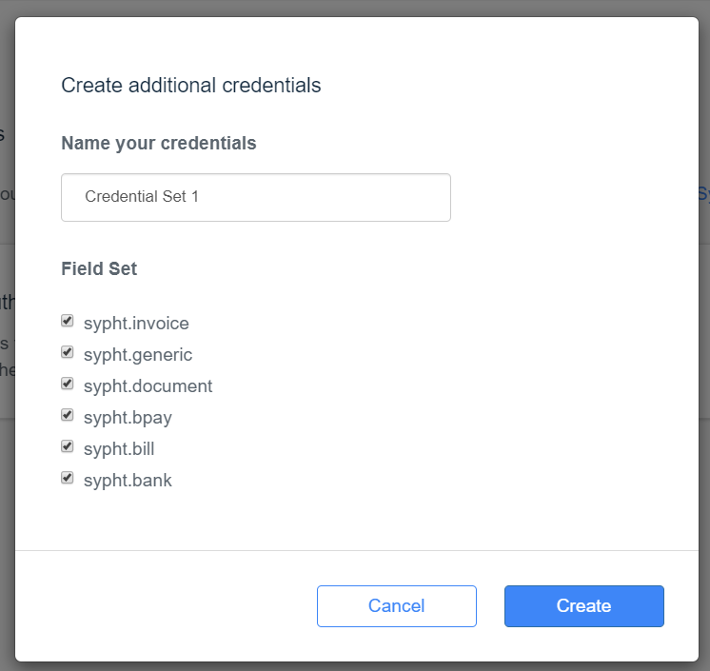

1. Note the auto generated Client ID and Client Secret and click Close (You can click on the copy icons to copy the Client ID and Client Secret which are required in the subsequent steps)

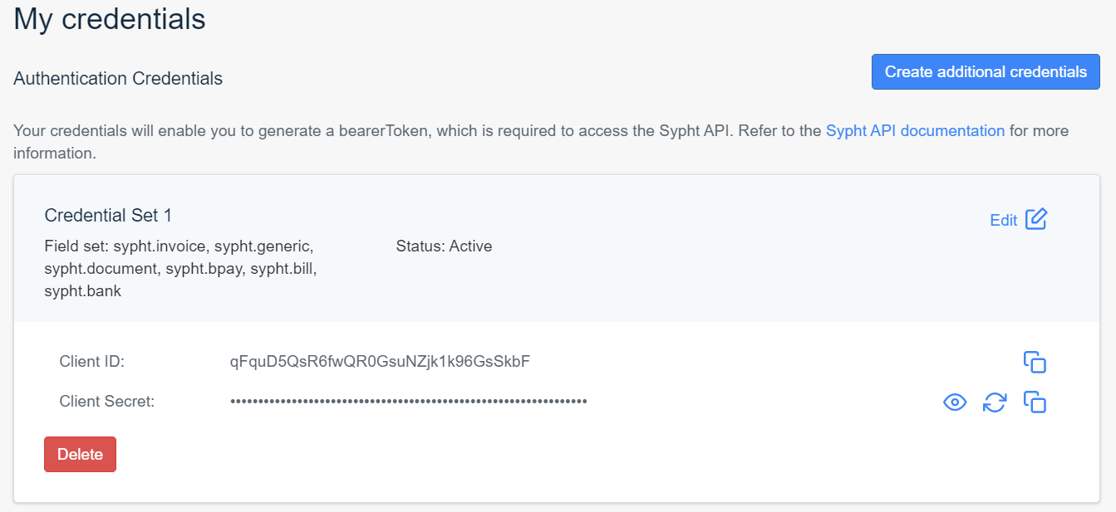

## Blue Prism Configuration

After you have imported the release into your Blue Prism environment, you must update the details of the Sypht credential template that was created for you in Credential Manager. The credential is named ***Sypht Client Details.***

To update the credential details:

1. Open Blue Prism Interactive Client
2. Go to ***System → Security → Credentials***
3. Double-click on the entry titled ***Sypht Client Details***
4. Enter the Client ID and Client Secret of the Sypht Client you just created.

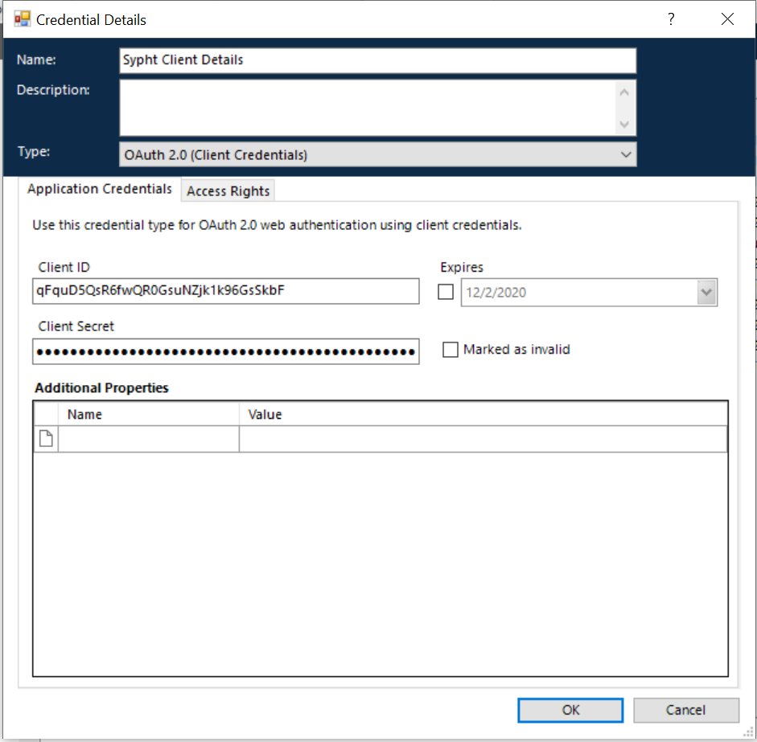

1. Next, click on the tab title ***Access Rights***.
2. Select an appropriate ***Security Role***, set the ***Processes*** that should have access to this credential, and specify which ***Resources*** can make use of the credential.

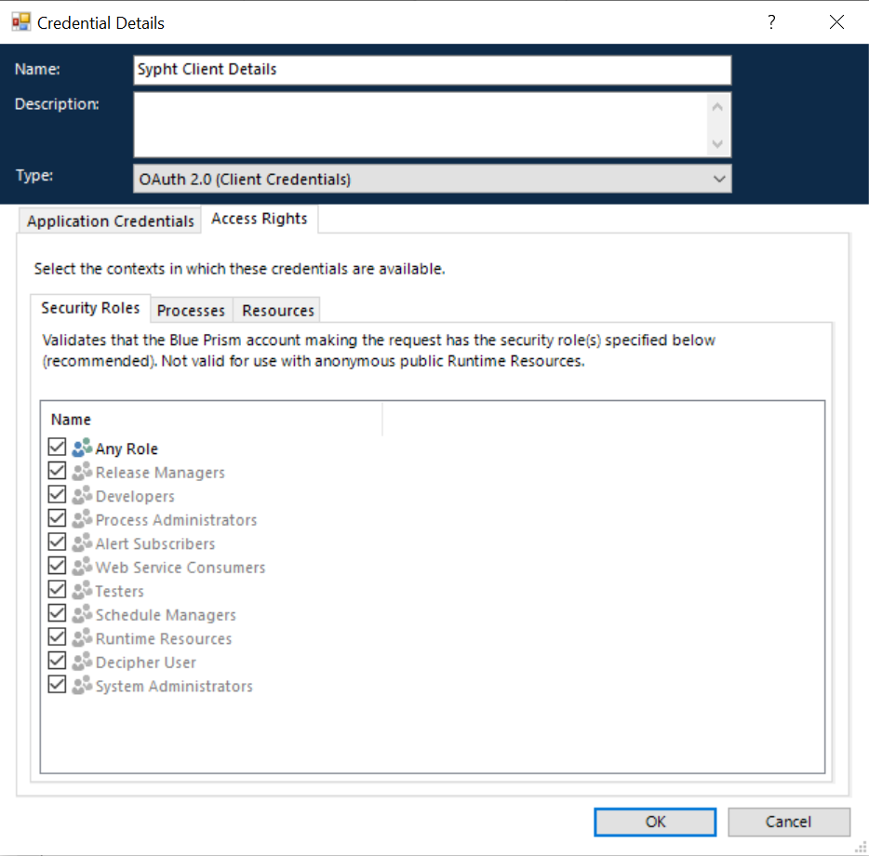

# Using the VBO

Below are the available actions in the VBO and the details of the inputs/outputs that are available. Further information about the Sypht API as well as response JSON format can be found at <https://docs.sypht.com/>

**NOTE:** The ***Get Access Token*** method is called internally by all other actions and is not published. This method retrieves a new access token if current token is expired and updates it in the credential named ***Sypht Access Token***.

## Upload File

This action will upload a document in either PDF, PNG or JPG format to the Sypht platform for extraction. Maximum file size supported is 20Mb and maximum pages per document is 16.

### Inputs

|  |  |  |
| --- | --- | --- |
| Parameter | Type | Description |
| Filename | Text | **Required** - Name of the file to upload |
| Base64 | Text | **Required** - Base64 encoded input file. |
| FieldSets | Text | **Required** - Field Sets to be retrieved from input file as comma separated input Eg. "sypht.document". |

### Outputs

|  |  |  |
| --- | --- | --- |
| Parameter | Type | Description |
| FileID | Text | Unique identifier for the uploaded file. |
| Success | Flag | Flag to indicate whether upoad was successful. |
| Error Description | Text | Error description in case upload was not successful. |

## Get Result Data

This action allows you to query the results gathered from Sypht's field extraction.

### Inputs

|  |  |  |
| --- | --- | --- |
| Parameter | Type | Description |
| FileID | Text | **Required** - Unique identifier for the uploaded file as received from Upload File action. |

### Outputs

|  |  |  |
| --- | --- | --- |
| Parameter | Type | Description |
| Result_Data | Text | JSON returned from HTTP request with the extracted data. In case of any exception this Data Item will have the exception details in JSON format. |

## Get Result Image

This action allows you to retrieve an image copy of the uploaded document.

### Inputs

|  |  |  |
| --- | --- | --- |
| Parameter | Type | Description |
| FileID | Text | **Required** - Unique identifier for the uploaded file as received from Upload File action. |

### Outputs

|  |  |  |
| --- | --- | --- |
| Parameter | Type | Description |
| Result Image | Image | Image of the uploaded file. |
| Error Description | Text | Error description in case upload was not successful. |

# Support

Support for this VBO is provided via the Blue Prism Digital Exchange Community Forum. Post your questions here:

[Digital Exchange Community Forum](https://community.blueprism.com/communities/community-home?communitykey=1e516cfe-4d1f-4de9-a9eb-58d15bf38c81&tab=groupdetails)

# Functional Tests

There is a simple test process supplied in the release file. This is to help you understand how you can implement the vbo in your solution. Note that the process uses Base64 encoder VBO to encode the input file as Base64. You can get the object from <https://digitalexchange.blueprism.com/dx/entry/9648/solution/base64encoder>

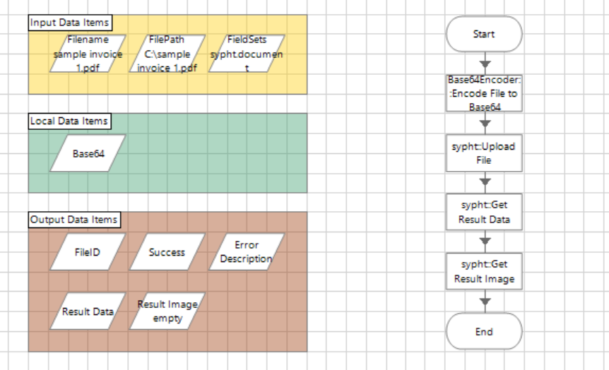

Sypht Process Example

# Troubleshooting Guidelines

Once you upload your document, sypht starts extracting the data from the document. It may take a while for sypht to extract all fields. If the field extraction is not complete yet, you will get not get the Status as “FINALIZED” in the JSON response for Get Result Data. It will be a good idea to implement this check in your process. You can use wait stages and loop to can the Get Result Data action again in your process to check the status again.

The sypht VBO has a dependency on these objects – Credentials, Utility – HTTP and Utility – JSON. As these objects comes as part of BluePrism installation, these have not been included in the release file.

# Frequently Asked Questions

There are no frequently asked questions at this stage.